Total Chaos PT
TC in the Print
Student-Athlete Centered Athletic Training | 11/2/2012 | [Edition 1, Volume 1]

Training Tip: Goal Setting
• • •
In order to be successful you need to know where you are at and where you want to go. With determination, planning and following some guidelines you can be on your way to SUCCESS:
When writing your goals you can use S.M.A.R.T to help set, define and organize your goals. S.M.A.R.T stands for the following:
S-Specific (write a detailed description of your goal) ex I will reduce my mile run from an 8 min mile to a 6.5 min mile within 60 days RATHER THAN I will run faster
M-Measureable (give the goal a number or measure) ex. you can see you are running faster because your goal is measureable from 8 minutes to 6 minutes
A-Attainable (make sure your goal is realistic) ex. I will run a 4.4 40 by next week is not a realistic goal when you run a 6.0 today. *But also make it challenging enough to keep you motivated to push yourself
R-Record (write down your goals) by writing them down you are making them real! AND Post it where you can see it daily
T-Time (time bound) give yourself a deadline. As sense of urgency helps to motivate

  - Are you ready for the Chaos?
The purpose of this program is to give student athletes the strength and conditioning to compete at a higher level in their specific sport while also providing opportunities to show good character, team work and good sportsmanship

What is Total Chaos Personal Training with CNS Athletics and CUSA? Dash Turner is a personal trainer with a unique set of skills and experiences that have allowed him to develop an athletic training program that has been adopted by CUSA (the Cicero United Soccer Academy and CNS Soccer and Hockey teams). The purpose of this program is to give student athletes the strength and conditioning to compete at a higher level in their specific sport while also providing opportunities to show good character, team work and good sportsmanship. This training program is about making well rounded athletes with strong minds, bodies and with a strong sports specific skill set.

******

SESSION THREE:
  - November 5, 2012

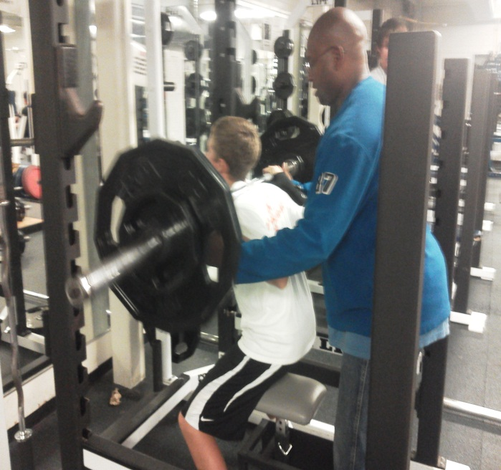
We are excited to start are third session of this academic school year. This session will start on Tuesday November, 6th at 6:30 pm. The training sessions will take place in the CNS High School weight room. There will be two additional training days on Wednesdays and Fridays, also at 6:30 pm. The price for this training is $150. This session will run November 6th- December 14th (Nov 19th will be a bonus day , as the rest of the week will be Thanksgiving Break and will not count as one of the weeks in the session). You must bring plenty of water, we prefer this to Gatorade or other sports drinks while working out and a pen. You will be asked to record your weights and reps on the provided record booklet.

Training Tip: Continued
• • •
When you are goal setting you want to set actions in place to keep you on track. You want two actions for every goal.
Ex Goal maintain 3.0 GPA Action 1: complete homework by 9 pm every night. Action 2: read/study 1 chapter over the weekend.
In addition to setting actions you want to create a written schedule. This can be in the form of a calendar, a planner or using your cell phone app. You want to know what is mandatory to finish each day, how much time things will take and also when you can have some free time!
If you are clear, realistic, motivated and organized; there is nothing you can’t accomplish!
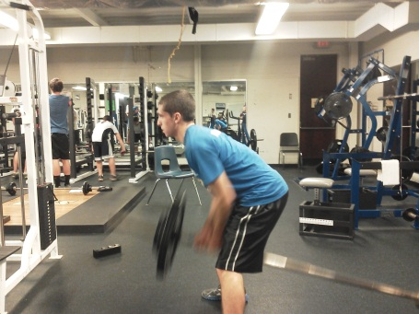
Currently we are training the CUSA athletes, CNS JV and Varsity Soccer and CNS Ice Hockey. If you are interested in having your team train with us please contact Lisa at lturner2316@verizon.net
For training information contact Lisa Turner at 561-3079 or email at lturner2316@verizon.net
Frequently Asked Questions
- Who is allowed to train with Dash?
For the CNS program and CUSA you must be a student in the CNS school district or a member of CUSA in order to train in this specially designed program. If you have friends and family who would like to train but they are not students, Dash has other programs that would fit their needs!

- What about girls sports?
We are so glad you asked! We will be starting the girls’ soccer program in January! We are very excited about this and cannot wait to see the girls improve their game and take it to the next level! If you have a girls team that wants more information on how to start a program, contact Lisa!

- Why should I participate, I already practice in my sport during the week?
Everyone’s goals and needs are different however; if you are interested in performing at a higher level in your sport additional training is highly recommended. During practice, you may do some conditioning, sports specific skills and drills and you will most likely go over game plan. Additional training provides the intense focus on building strength, speed, agility and in some cases size in order to compete at that higher level. Our goal is to provide your student athlete with the tools necessary to perform at a high level at any college camp, tryout or scouting event; while also preparing you for high level high school play. We have college in mind! Not everyone is interested in playing their sport in college but preparing to play at the top of their game in high school will have them ready if that is one of their goals!

- Is Dash always this cookie crazy?
Having lived with him for over 13 years I can say, he is that crazy on most days! Just kidding, he truly enjoys working with the kids and is always dreaming up new ways to challenge and push them to make them better. But, HE IS ALWAYS THAT LOUD. You can hear him before you see him!

