# **Ho Ho Ho Happy Holidays**

# Training Tip: The Three R’s

• • •

Rest <>Recharge<>Re-evaluate:

As you all know we are coming up on the end of our current session and will be entering a 3 week hiatus. This can be a blessing but it also can be a down fall if you do not use the time properly. Here are some things to think about as you take some time off.

**Rest:** Rest is important all the time whether or not you are coming off a training program or while you are in one. Studies show that most people do not get enough sleep for their age and training level. Teens should be seeing about 8.5 to 9 hours of sleep according to the Kidshealth.org and the National Sleep Foundation. Athletes stress their bodies more and will require more sleep to help repair their bodies. Teen Athletes should get at least 10 hours of restful sleep. Some things to avoid before bedtime to ensure a more recuperative sleep: Avoid stimulants such as caffeine and sugar after 4 pm. Avoid violent, action packed or scary movies before bed. You also want to avoid TV, phone, computers, action packed books and video games at least an hour before bed. Then, you will want to set the tone for your brain to signal your body to wind down. Set a bed time, keep your lights low, meditate or listen to soothing music and unload your mind of your daily activities. Journaling helps with that!

***TC in the Print***

|  |  |  |
| --- | --- | --- |
| **Student-Athlete Centered Athletic Training** | **12/6/2012** | **Edition 1; Volume 2** |

Are you ready for the Holidays?

There is no doubt that the holiday season can be a time of joy and togetherness but it also can be a time of stress. We have busy schedules, lots of shopping, parties, cooking, decorating and more. In order to not let the holiday season get away from us and to be able to really enjoy the time with friends and family; according to an article on msn.com here are 7 tips to keep the fun in and the stress out: **1. Get enough sleep.** Sleep deprivation is a major disturber of people’s moods. Making an effort to get to bed at a decent hour really pays off. **2. Exercise**. Studies show that one of the quickest and surest ways to boost your mood is to exercise. If you are away from home and can’t do your usual routine, even a short walk will help. Even better, exercise outside, where the sunlight will help improve your mood and focus. **3. Stay in control of your eating.** It seems that guilt about holiday binging is a major source of the blues. It’s important to know ahead of time what you plan on doing. If you are going to indulge, let yourself off the hook to not feel guilty about it. If you set up a plan ahead and stick to it, there is no sense of guilt because you know ahead of time what you were going to do. **4. Take your time; plan ahead.** Hurrying to pack, rushing through the stores, sprinting to make a flight-these are sure to put you in a bad mood. Try to give yourself plenty of time to do what you need to do. **5. Learn from the past.** What has made you unhappy in years past? Think back. Avoid your triggers. Stay out of the kitchen, or the mall or away from Uncle Billy-sometimes there’s a weird triumphant satisfaction in getting worked up, but DON’T DO IT! Don’t expose yourself to known unhappiness risks. **6. Make time for real fun.** Figure out ways to have fun. Whatever it is you enjoy, make time for it. Go to a movie, visit with a friend, take a nap or workout. Just don’t consume yourself with your to-do list! **7. Stay true to you**. The biggest thing you can do to stay stress free is stay within your means. This means financially, emotionally and physically. We are all only human! If we stay within what we know we can do, we won’t be stressed by over doing it!

*Stay true to you. The biggest thing you can do to stay stress free is stay within your means. This means financially, emotionally and physically. We are all only human! If we stay within what we know we can do, we won’t be stressed by over doing it!*

# Training Tip: Continued

• • •

We will talk more about sleep in another newsletter. Once you get your sleep pattern set and you are getting the most restful sleep you can, you can help ensure you are:

**Recharging*:*** Part of recharging is out of your hands. When you sleep your body does the work for you. However, just like setting up successful sleep patterns we also need to do our part while we are awake to help in the process. One thing you can do is to reduce the amount of outside stress you put yourself under. Understand your limitations physically, emotionally and time wise. Being organized by keeping a calendar or schedule to manage your time will help to ensure you are keeping within your limits. Second, you want to make sure you are fueling your body with the right kinds of foods. There is a lot of information out there on what to do and what not to do. An easy rule of thumb is to moderate. You do not want to only eat processed, sugary foods. You want to make sure you are eating 2/3 the amount of whole, real foods then you are of processed sugars and pastas. Eat small meals and eat frequently. You can carry around a small back of nuts or carrots and snack on a few in between meals. Just that little step will ensure that your body doesn’t start to think it is starving and store all you eat as fat. Our bodies are really smart. They have an automatic survival mode and when you skip meals or go long periods in between; to survive it will store everything you eat as fat so that later when it does not have any food, it has fuel to the important process in your body going. It does not take long to program your body to do this. Nor, does it take long to un-program it…you just need to prepare!

# SESSION FOUR:

January 15, 2013

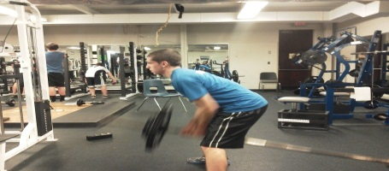 The boys have been doing exceptionally well with the book format in the weight room. Dash is seeing an increase in strength across the board. In session four we will be continuing work with explosive movements and strength building exercises. It is really important for each athlete to be recording the sets so that they can see the growth, where they are strong and the areas that need to be focused on. In the upcoming session you (athletes) should take a few moments with Dash to look over the book and make sure that you are at the correct weights and reps for each exercise. In session 5 we will be changing the layout to include a speed and conditioning day. That means you will spend two days in the weight room and one in the gym. Please note that we will be changing ***Monday’s workout to Tuesdays*** as Dash will be taking one of his college courses. I will of course send out reminders as we get closer to the start date. The 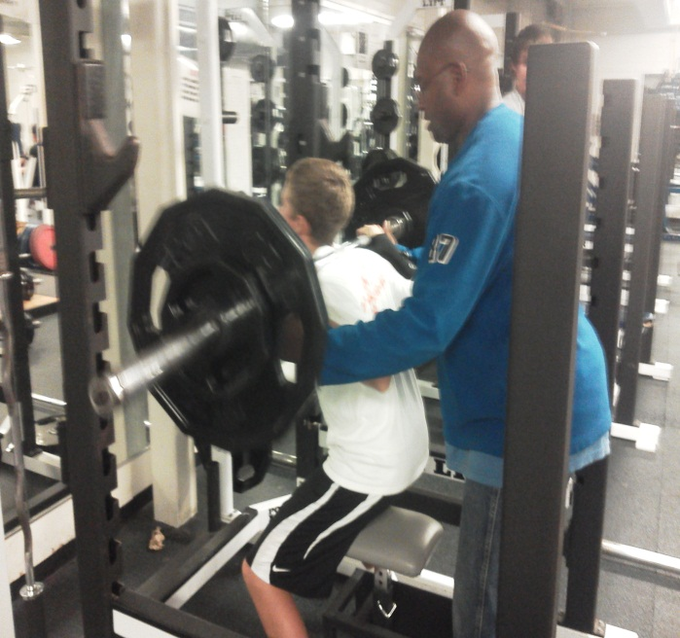price for the training is $150. This session will run **January 15th- February 15th. Dates will be Jan 15, 16, 18, 22, 23, 25, 29, 30 and Feb 1, 5, 6, 8, 12, 13, 15.** Time will stay at 6:30, with an additional time slot at 7:30 depending on the number of boys resigning. Please keep an eye out for the email!

Welcome Girls Soccer!

We are so excited to be adding our Girls Soccer Program to our Strength and Conditioning Session 4! Parents if your daughter is interested in training with Dash during the upcoming session we will be having an informational meeting on January 10th after practice (7-8pm @481 Sports Center). Dash will be there to answer questions regarding the program goals, his philosophy and a little bit about himself. The girls will train in the 5:30-6:30 time slot on the same days as the boys.

# Frequently Asked Questions:

1. **Who is allowed to train with Dash?**

*For the CNS program and CUSA you must be a student in the CNS school district or a member of CUSA in order to train in this specially designed program. If you have friends and family who would like to train but they are not students, Dash has other programs that would fit their needs!*

1. **What about girl’s sports?**

*We are so glad you asked! We will be starting the girls’ soccer program in January! We are very excited about this and*

1. **Why should I participate, I already practice in my sport during the week?**

*Everyone’s goals and needs are different however; if you are interested in performing at a higher level in your sport additional training is highly recommended. During practice, you may do some conditioning, sports specific skills and drills and you will most likely go over game plan. Additional training provides the intense focus on building strength, speed, agility and in some cases size in order to compete at that higher level. Our goal is to provide your student athlete with the tools necessary to perform at a high level at any college camp, tryout or scouting event; while also preparing you for high level high school play. We have college in mind! Not everyone is interested in playing their sport in college but preparing to play at the top of their game in high school will have them ready if that is one of their goals!*

*Cannot wait to see the girls improve their game and take it to the next level! If you have a girl’s team that wants more information on how to start a program, contact Lisa!*

1. **What is Dash’s favorite pastime?**

*Aside from watching his kids play their sports and watching his FAVORITE NY GIANTS whoop on ‘dem Cowboys he loves loves loves personal training! He likes to see someone come in with a goal and help them to achieve it! The change is always exciting!*

*Currently we are training CUSA Athletes, CNS Boys Soccer, CNS Boys Hockey. If you would like your team to train, contact Lisa Turner at* [*lturner2316@verizon.net*](mailto:lturner2316@verizon.net)

***HAPPY HOLIDAYS FROM THE TURNERS!***

*C:\Users\Lisa\AppData\Local\Microsoft\Windows\Temporary Internet Files\Content.IE5\1U0G02SC\MC900030715[1].wmf*

# Training Tip: Continued

• • •

Lastly, you want to hydrate your body to aide in your **recharge**. The best thing you can put into your body is water. In a male of average weight, water is 57% of his total body weight. Our bodies need water. Soda, sports drinks, milk or other beverages have their place in our diets but water is what it needs to work properly and recharge. Studies show that by the time our brain signals to us that we are thirsty it is already too late. You need to have a steady flow of water throughout the day. Slamming a days’ worth of water in your system at once will only overfill your bladder. Give your organs what they need and drink your water over the course of your day.

Our last R is to: **Re-evaluate*:*** in the last newsletter we talked about goal setting. Apart of goal setting is to continually re-evaluate your goals to make sure that you are on the right track. You might find that you are working towards your goals in a proper amount of time, or that you have met your goals or that the goals are no longer appropriate for the time frame you have allotted. Goals are on a continuum. They are meant to move and change with your needs. As you reach goals you will need to set new ones. This is how we grow as people, athletes and lifelong learners!

So over your 3 week break don’t just sit down and veg in front of the TV. Work on your three R’s every day. Your body and mind will thank you!

P.S….you still want to do some light exercise every day. It could be a walk, take a class, shoot some hoops, lift some light weights or go for a jog! Just don’t overdo it. You want to keep your body moving and active! See you all in January ☺