TC in the Print

When should you start preparing for collegiate sports? The answer to this question is simple…YESTERDAY! If you are not sure if you want play in college but have the slightest interest in playing sports in college you need to start preparing now if you haven’t already. Your competition started preparing yesterday, last month or years ago. Preparing for the possibility of a scholarship in your sport is a real goal for many student athletes. In order to be at the top of your game, get exposure and start making steps towards college prep now. You will need to play in your sport more than just for the season. You will need to participate in strength and conditioning program, do well in school by keeping your grades up and participating in other activities. And, you will need to attend skill and prospect camps becoming more selective as your get further into your high school career. This month’s special edition newsletter is about skill and prospect camps. If you have any specific questions please feel free to email me at lturner2316@verizon.net .

Three Reasons to Attend Sports Camps
You’ll Improve Your Skills
Whether you attend a general camp or a focused camp, you’ll have the chance to learn new things from new coaches and practice against different players. They may have things to teach you, as well. Attending a camp allows you to get in some practice at a higher level of play which in turn can help sharpen your skills. Additionally, attending a focused camp will allow you to spend quality time on that particular skill with a coach or instructor that focuses on that aspect of the game.

You’ll Make Connections
Much like the career world, networking is the key to getting better jobs, with better pay and benefits. Attending a camp, even if the camp isn’t a recruiting camp, will still give you a chance to work with college coaches from your area and surrounding areas. This can give you an in when you are sending out highlight DVDs later. If the coach recognizes you from camp, he may spend more time with your application than if you are a total stranger to him. You’ll also meet other players who are as dedicated to the sport as you are, and they may have good advice or leads that can help you. You will want to look at every opportunity at a camp as a chance for you to network, learn and prepare for the next step.

You’ll Be Seen
Attending a showcase or prospect camp is a great way to get yourself out there and seen by recruiters and coaches. Remember that while these two types of camps are similar, they differ in an important way. Both camps will have coaches or recruiters present to scout for talent. A prospect camp will only have coaches or recruiters from the school hosting the event. A showcase will include coaches or recruiters from multiple institutions. If you already know where you want to go, attending a prospect camp at that school is great. If you don’t know, or want to be seen and considered by multiple schools, a showcase is a better choice, as it will include coaches from different schools.

Preparing for a Prospect Camp
If playing collegiate sports is something that you dream of, then register for a summer camp prior to your senior year. The earlier and more often you attend camp during high school the more you’ll benefit from the experience later. Going to camp during your 9th or 10th grade year will help you gain knowledge of what to expect at a camp. If you perform well enough before your 11th grade year your chances of being recruited increase.
Let the Coaches Know You are Attending Their Camp
Camps can draw several hundred athletes, and speaking with a coach beforehand lets him know you are serious about earning a scholarship. A call shows initiative and a coach may go out of his way to evaluate your skills.

Don't Neglect the Intangibles Intelligence, Character and Mental Toughness
While coaches are judging a player's talent, they're also noting nonphysical skills. Say "thank you" and "sir" when speaking with the coaches, always hustle and don't use curse word

Be Humble at Sports Camps
At your particular high school you might be “The Man”, but college sports are huge. Camps have some of the best athletes in the country not just some of the best athletes in your area. A big time university camp will at the very least let you know where you stand against elite competition and what you need to improve on. You want to preform your best but also walk away with a list of things you can improve on. Make sure that you always shake the coach’s hand and thank them for having you. If this college is a place you are interested in attending, follow up the camp with a note or email to the coach.
Go Sports Camps in Great Shape
A mistake that high school athletes make at these camps is putting on too much weight to look the part, prior to when camp starts. Players will put on this extra weight and not perform well in drills and testing due to the excess weight. If you’re an athlete, university coaches will find a way to get you on the field and eventually you will grow into your body.
Don’t Believe the Hype
Websites like TopProspects.ca, Rivals.com and Scout.com try to provide an in-depth analysis on particular athletes. Once camp starts though, college coaches only use these websites as a point of reference. A player may go into a camp as a big time prospect but when he starts to perform, that high ranking disappears really quickly. If you are a highly ranked prospect, you should be congratulated but you have to leave all that hype behind you once you step onto a university campus and perform at your highest level.
Make a Good First Impression
A camp or combine is like a job interview, it is your chance to showcase your talents to an interested employer. It is important that you don’t come across as somebody that the coaches and potential teammates despise. Athleticism is one part of the evaluation process; but if you’re the guy who is going to complain after every drill, then they will find someone else. Pay attention to the coaches and the university staff members at all times, be a good guest, someone that they would like to have come back. For the few days that you are attending the camp act like you want to be there; put your complete focus on the camp, and stay away from the internet, your cell phone and video games.

Sports Camps Are Tryouts
A university camp is basically a tryout. You are being coached by them in their drills, on their home field and in their language and terminology. At some camps, university coaches run them like they run a regular university practice with their position coach heading up each drill. This is for a coach to not only see what kind of an athlete a kid is, but also how he responds to instruction and criticism. For example, if you’re a defensive back or mid-fielder and you get beat on a play, don’t sulk and show your frustration through your body language. Always stay positive and just move onto the next play. Prove to the coaches that you’re coachable and that you have a positive attitude.
Do You Have What They’re Looking For?
University coaches look at every detail to show them if a particular kid can develop into a big time player for their program. University coaches want athletes that can run and jump, but change-of-direction is a crucial attribute that coaches are putting more and more emphasis on. Coaches are always watching your mannerisms and coach ability. If an athlete makes the same mistake over and over again after being told not to do it, which can send a red flag to a university coach. Here are some other questions a coach may have when they meet amongst themselves:
Do they have great anticipation?
What type of leader are they?
Are they tough enough?
Did they make friends at camp, or did they hang out by themselves?
Did they compete?
The list of things that coaches look for is extremely long, but the desire and ability to compete is always at the top of their list. If you do well in one-on-one drills a coach will definitely remember your name.
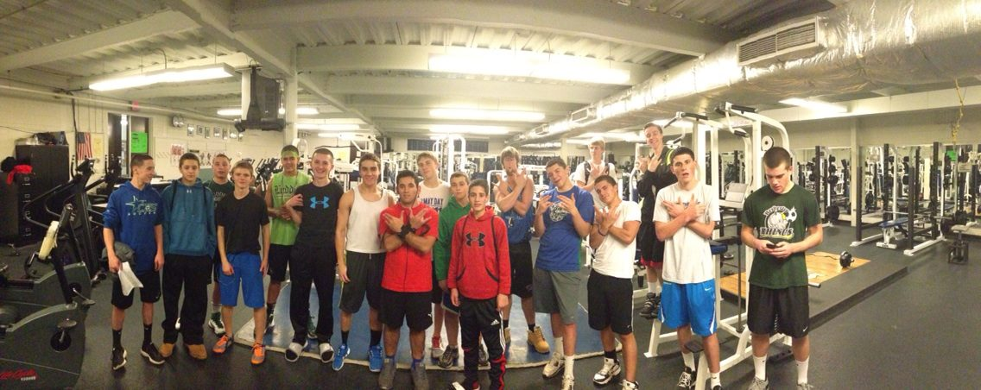

Make Sports Camps a Learning Experience
Sometimes when going to a camp we get so caught up with trying to get a scholarship that we forget why we are there in the first place, to receive instruction from university coaches. By attending these camps you should acquire tips to help make you a better player during the upcoming season. Learn the drills and take in the coaching to help refine your technique for the future.
Be Realistic At Sports Camps
Every player hopes and prays that they will get offered a scholarship at one of these camps. Have a fun time at camp but treat it like a job interview, but remember that most athletes will not receive a scholarship at these camps. If there are 300 kids at a camp, maybe 5- 10 will receive an athletic scholarship. A realistic goal to achieve is to land on a schools’ radar. If you perform well enough, you can land on that schools’ recruiting board so coaches will contact you and watch film of you during the season. What you do in summer camp is great but film will never lie, so if you excel at a camp, make sure you excel on during the upcoming season because coaches will be watching.
What camps are you attending this summer? What are you expecting to get from the camp?
Questions for Dash: The King of Chaos
1) Is the training hard core or is there some fun involved too? The training is hard core. I love to push my athletes to the edge because this is what increases your skill, strength and ability and makes you better to play at the top of your game. My goal is to have everyone who wants to make it to college and play their sport! But, I am wild and crazy. I like to dance around, play the music loud, and make up my own lyrics while we train. It’s fun and you never know what I am going to say or do…come join chaos!
2) Who's harder to train boys or girls? Neither! I think they are different but equally as hard. With boys their testosterone takes over and they want do too much too fast! With the girls, they are more hesitant to lift but once they get going they are all good.

